**AIPP LAB 3**

**Name: MAHVISH ISAQ**

**Hall Ticket No.: 2503B05134**

**Date: 28/10/2025 (Week 1)**

**______________________________________________**

**Task 1:**

**Application for TGNPDCL**  
**Objective:** Build an application using the Python program for TGNPDCL, to generate the bill based on energy consumption and type of customer with the help of AI tools. Build a python application as per below instructions  
• Read all the required data like PU,CU and Type of customer  
• Calculate bill amount based on number of units consumed, type of customer  
and other charges  
• Finally print the values of EC(Energy Charges),FC(Fixed  
Charges),CC(Customer Charges),ED(Electricity Duty Charges),bill as per  
expected output  
**Requirements:**  
**•** VS Code with GitHub Copilot or Google Colab with Gemini  
• Students should bring power bill from their home  
**Deliverables:**  
**•** Print energy bill for given inputs and verify with bill taken by students

***PROMPTS:***

**1) Generate the complete Python code for this electricity bill calculator.**

**2) Add detailed bill printing format and include customer name input.**

**3) Print EC, FC, CC, ED, and Total Bill neatly for the entered inputs.**

**4) Print Clear Bill Summary.**

***CODE:***

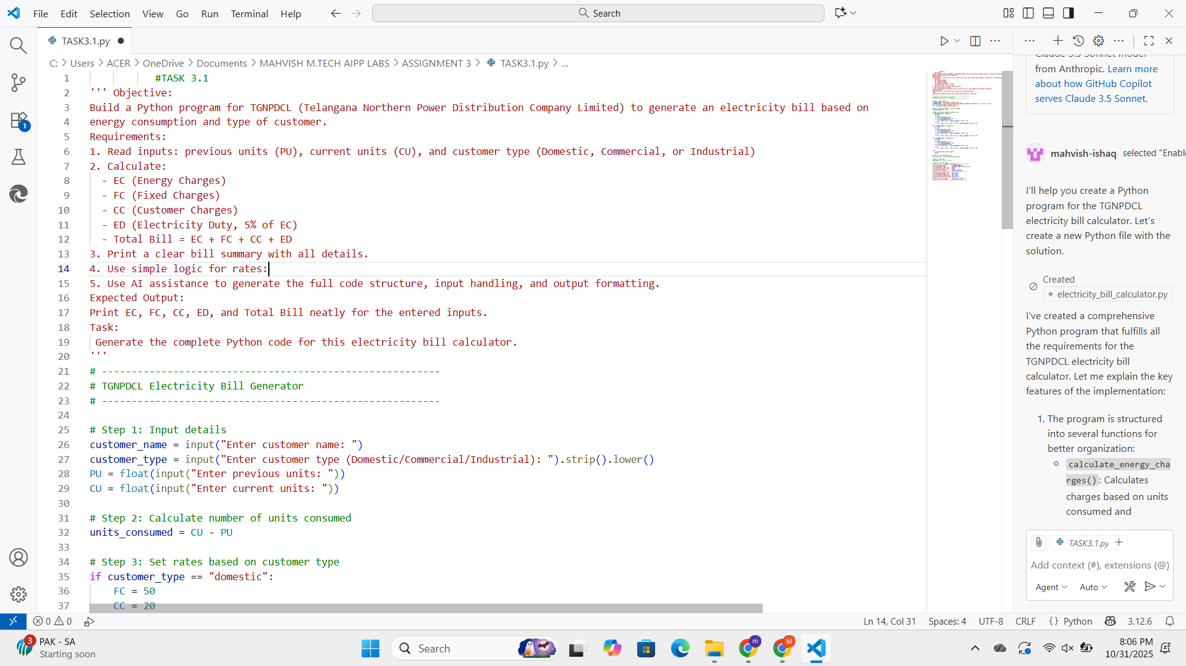

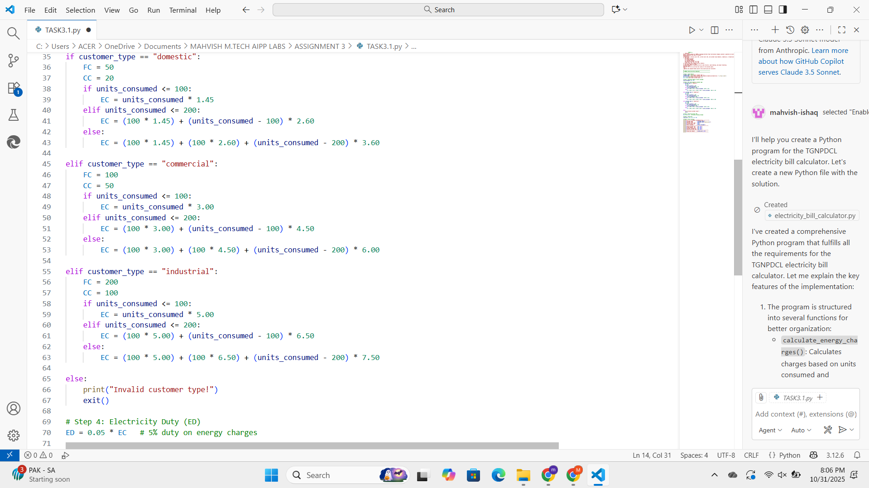

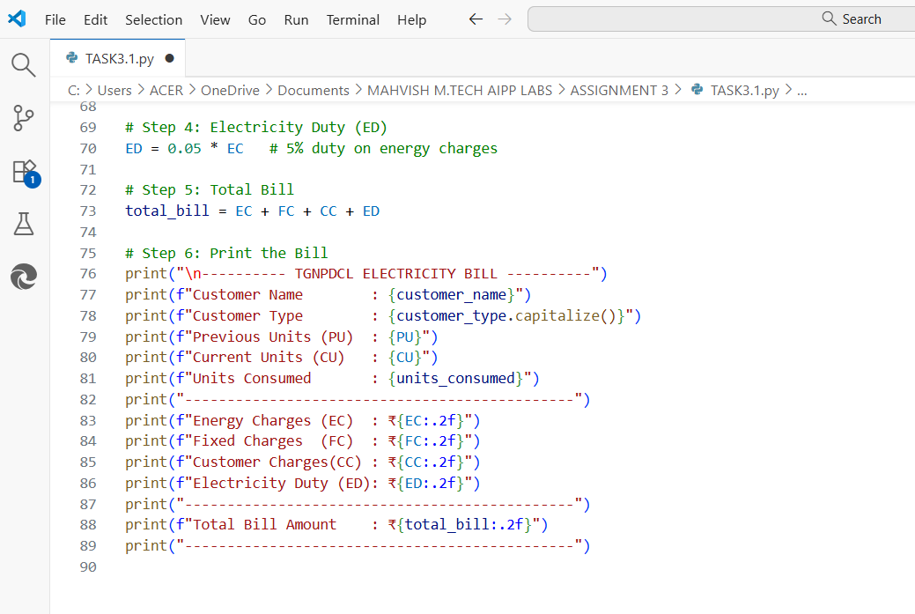***OUTPUT:***

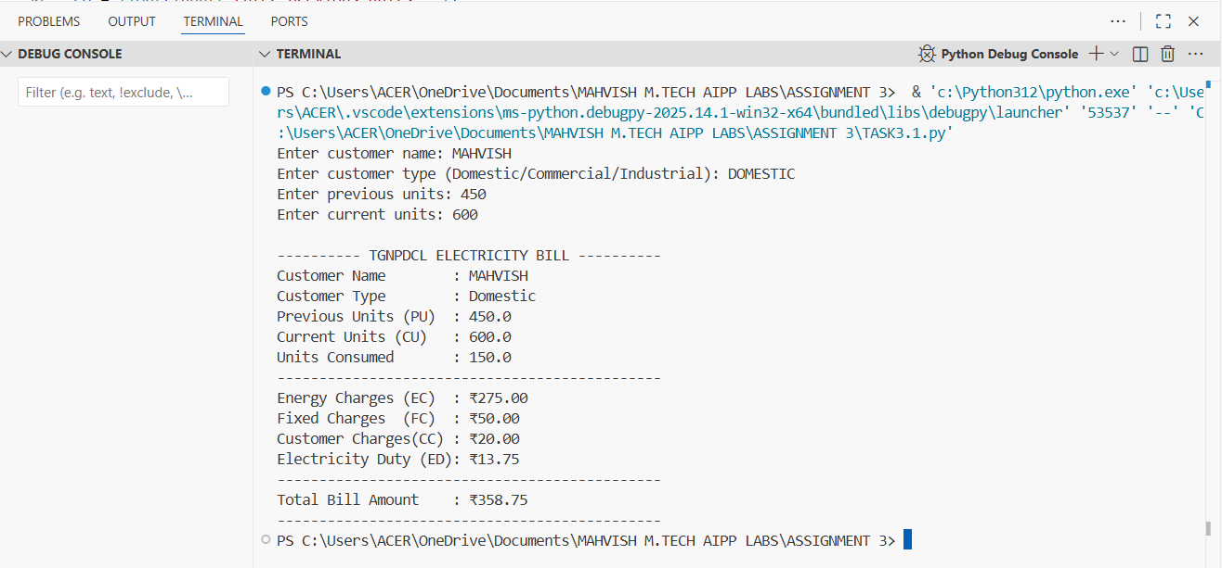

**\*\*\*Comparison is done between my home bill and this Electricity Bill Generator. It showed the correct values as in my bill.**

**________________________________________________________________**